 **Principle Database Management**

**FINAL REPOT**

**TOPIC 4: Advanced Employee Management**

**(PhD.Nguyen Thi Thuy Loan – PDM G01 Friday)**

**Group 05’s members:**

Trương Thái Ngọc Toàn (Leader) ITDSIU19057

Lý Minh Trung ITDSIU19023

Mai Đặng Nhật Anh ITDSIU19031

Phan Hưng Thịnh ITDSIU19055

**Contents**

**1.** **OVERVIEW** 2

**2.** **ANALYZINGTHE REQUIREMENT** 2

**Our database has:** 2

a) **Admin:** Company willprovide account to them for keep track other employees with several functions: 3

b) **Employee**: Company also provide the account to employee for seeing their: 3

c) **Salary**: show all elements to compute salary per month 3

d) **Attendance**: show in that month, in that date who are signing in for attendant 3

e) **Login**: Admin and Employee will provided account to sign in application 3

**Some relationships between entities:** 4

**3.** **ERD** 4

**4.** **RELATIONAL MODEL** 4

**5.** **CONCEPTUAL SCHEMA** 5

**a)** **Database Diagram:** 5

**b)** **Relationship** 5

**6.** **CREATE DATABASE:** 6

**a)** **Create ID for each table:** 6

- **Login:** 6

- **Admin**: ADAC.TA 6

- **Employee:** EMAC.TA001 6

- **Admin_Contact , Employee_Contact:** ADAC.TA.CO and EMAC.TA001.C0 6

- **Attendance:** EMAC.TA001.01.15 6

- **Salary:** EMAC.TA001.01 6

**b)** **Sample Data** 6

**Login:** 7

**Admin:** 7

**Employee:** 8

**Ad_Contact:** 8

**Employee_Contact:** 9

**Attendance:** 10

**Salary:** 11

**7.** **JAVA APLICATION** 11

**a)** **Login:** 11

**b)** **Admin Interface**: show the list of Employee and their information, attendance, salary 12

**c)** **Employee Interface**: Just show for 1 employee base on Username 14

**8.** **CONCLUSION:** 15

**9.** **REFERENCES:** 16

1. **OVERVIEW**

One of the most necessary things which companies care about is how to manage their employees effectively. Have you ever heard of a company that does not have a clear HR (Human Resources) management system affecting its financial income and leading to a loss of company revenue? The core of a company is its human resources. So it is not too difficult to understand when any company needs to have an HR management system. That is why we are here with that system that easy to manage all personal information. Currently, it is a system that can help users to view all personal information as well as work progress, salary, or edit data and will develop more functions in the future.

Typical users and their activities in the system:

Admin: edit data, view all personal information of the employee and another admin.

Employee: view all personal information.

1. **ANALYZINGTHE REQUIREMENT**

**Our database has:**

1. **Admin:** Company willprovide account to them for keep track other employees with several functions:

* Add a new employee after recruitment, remove employee if they don’t go to work anymore.
* Calculate employee’s salary base on their attendance and their salary amount.
* Admin can see a list of employees whose are managing

1. **Employee**: Company also provide the account to employee for seeing their:

* Information ( ID, name, gender, date of birth, address, contact, department, salary)
* Salary
* Attendance

Employee also can suggest their idea to manager for improve the company (

1. **Salary**: show all elements to compute salary per month

* Salary_ID
* Salary amount.
* Bonus
* Allowance.

1. **Attendance**: show in that month, in that date who are signing in for attendant

* Attend_ID
* Date
* Month
* Absences

1. **Login**: Admin and Employee will provided account to sign in application

* Admin will have user name Admin
* Employee will have user name as thier ID
* Password default is 1

**Some relationships between entities:**

1. Admin can manage many employees, but employee just has 1 admin for keep track ( 1 to many)
2. Admin can comment evaluation many employees, employee also can comment evaluation many admins ( many to many )
3. Employee has many day to check attendance, attendance has many employee for registed
4. Employee just has many salary to see ( each salary per month ), salary has many employees have same amount.
5. **ERD**

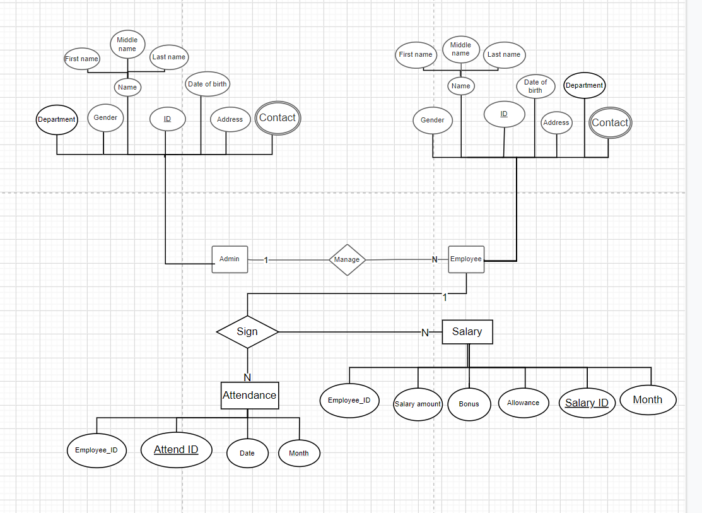

1. **RELATIONAL MODEL**

Admin ( Ad.ID, Department, Gender, First name, Last name, Date of birth, Address)

Employee ( Em.ID, Ad.ID, Gender, First name, Last name, Date of birth, Address)

Admin.Contact ( Ad.ID, Email, Phone)

Employee.Contact (Em.ID, Email,Phone)

Salary ( Salary.ID,Em.ID Salary amount, Bonus, Allowance,Month )

Attendance( Attend.ID, Em.ID, Absences, Date, Month )

1. **CONCEPTUAL SCHEMA**
   1. **Database Diagram:**

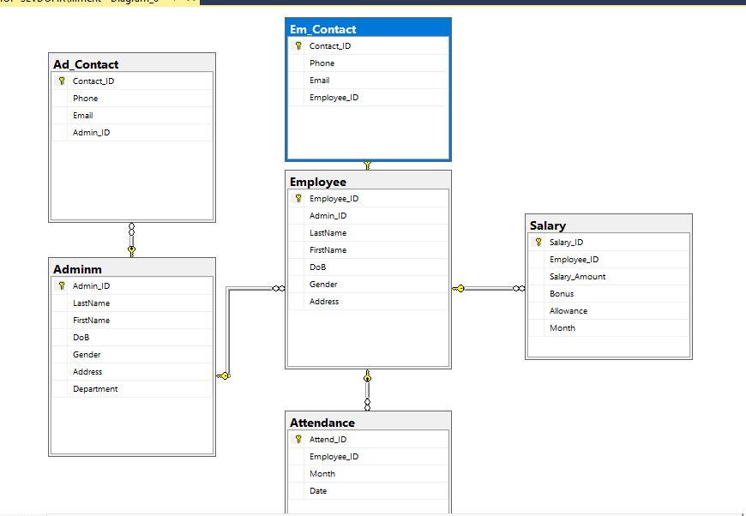

* 1. **Relationship**

**Admin** ( Ad.ID, Department, Gender, First name, Last name, Date of birth, Address)

**Admin.Contact** ( Ad.ID, Email, Phone)

* From Admin.Contact (Ad.ID) to Admin (Ad.ID)

**Employee** ( Em.ID, Ad.ID, Gender, First name, Last name, Date of birth, Address)

* From Employee (Ad.ID) to Admin (Ad.ID)

**Employee.Contact** (Em.ID, Email,Phone)

* From Employee.Contact (Em.ID) to Employee (Em.ID)

**Salary** ( Salary.ID,Em.ID Salary amount, Bonus, Allowance,Month )

* From Salary (Em.ID) to Employee (Em.ID)

**Attendance** ( Attend.ID, Em.ID, Absences, Date, Month )

* From Attendance (Em.ID) to Employee (Em.ID)

1. **CREATE DATABASE:**
2. **Create ID for each table:**

* **Login:**

+ Admin: Username: Admin

+ Employee: User Name: EMAC.TA001 ( using Employee_ID to username account )

* **Admin**: ADAC.TA

+ AD represent to Admin ( Position )

+ AC represent to Department ( Accounting )

+ TA represent to Our Company

* **Employee:** EMAC.TA001

+ EM represent to Employee ( Position)

+ AC represent to Department ( Accounting )

+ TA represent to Our Company

+ “001” represent to ordinal number ( just seven employee at the beginning, if other employees are recruited, the ordinal number will continue to increase base on time they join the company)

* **Admin_Contact , Employee_Contact:** ADAC.TA.CO and EMAC.TA001.C0

+ Add “.CO” after Admin_ID or Employee_ID ( CO represent to Contact )

* **Attendance:** EMAC.TA001.01.15

+ Add “.01.15” to Employee_ID

+ 01 represent to month

+15 represent to date

* **Salary:** EMAC.TA001.01

+ Add “.01” to Employee_ID

+ 01 represent to month

1. **Sample Data**

## **Login:**

## **Admin:**

## **Employee:**

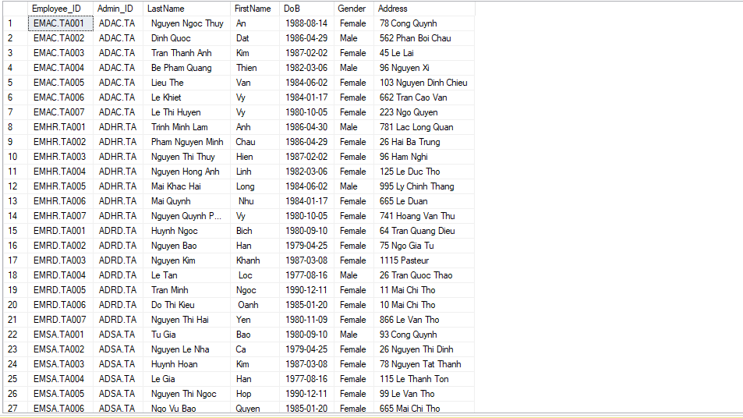

## **Ad_Contact:**

## **Employee_Contact:**

## **Attendance:**

## **Salary:**

1. **JAVA APLICATION**
2. **Login:**

* The company will provide to admin or employee to sign in the Application

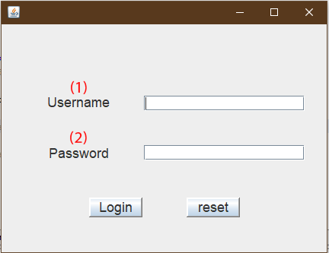

1. To put username
2. To put password

* **Admin sign in:**

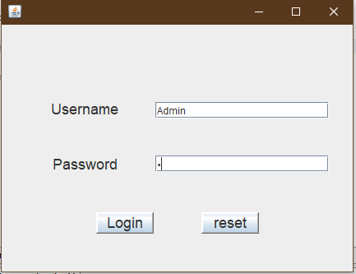

* **Employee sign in:**

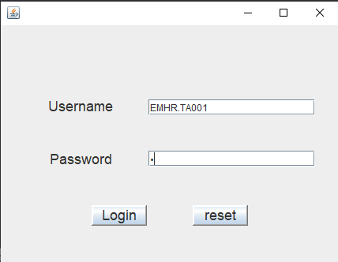

1. **Admin Interface**: show the list of Employee and their information, attendance, salary

* **Admin Information**

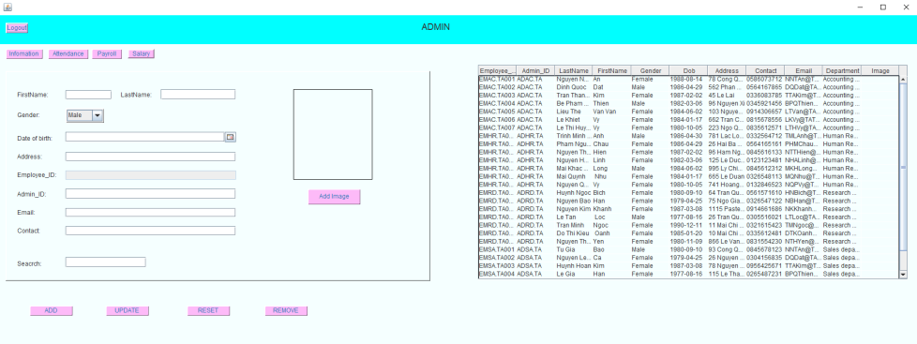

* **Admin Attendance:**

* **Admin Payroll:**

* **Admin Compute Salary:**

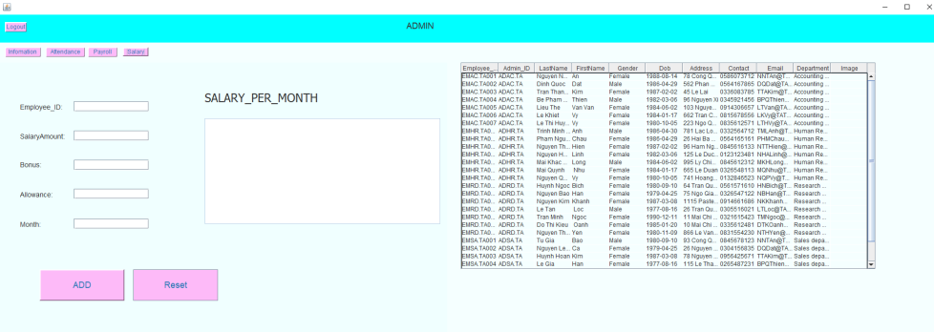

1. **Employee Interface**: Just show for 1 employee base on Username

* **Employee Information:**

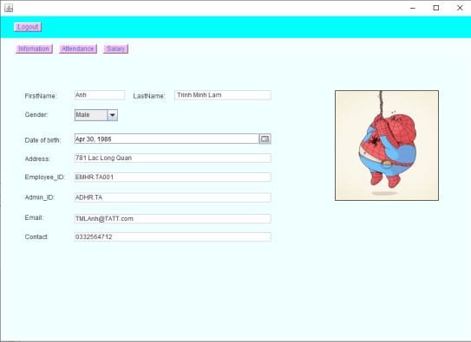

* **Employee Attendance:**

* **Employee Salary**



1. **CONCLUSION:**

In this project, we have built a system of Employment Agency where employers can post their vacancies, employees can browse or search suitable vacancies based on their attributes. The system is created by using SQL Server database, JDBC, and the knowledge that we archived from the Principle of Database Management course.

1. **REFERENCES:**

*The Course: Principles of Database Management, Lab 5-6-7*

<http://netbeans.apache.org/kb/>

https://www.javatpoint.com/java-swing